Step 1)

Download all the .ASM file, MASM.EXE, LINK.EXE and DEBUG.EXE to your C DRIVE and file 8086 or any file you want in your laptop or pc.

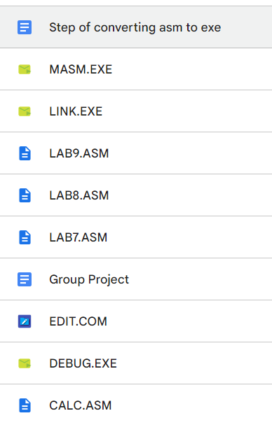

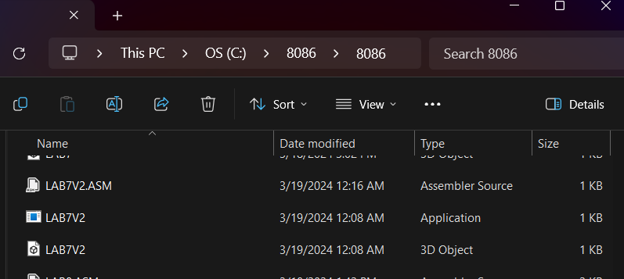

Step 2)

Follow the command line show in the figure below

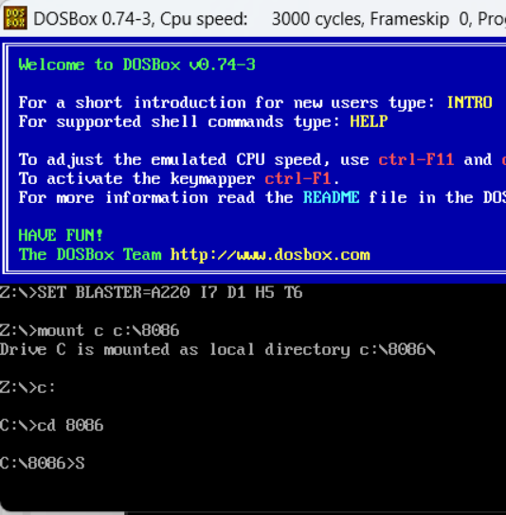

Step 3)

Key in the command line MASM [filename.ASM] , and then press enter three times

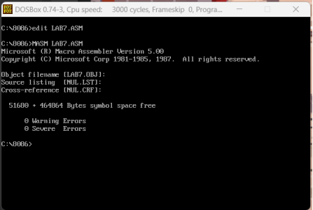

Step 4)

Key in the command line LINK [filename.OBJ] , and then press enter three times

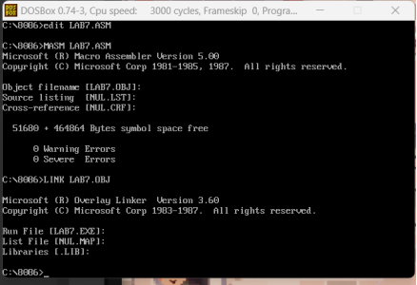

Step 5)

Key in the command line DEBUG [filename.EXE] , the exe file is executed and can start do the lab 7 to 9.

